Packet Tracer – Configuring Multiarea OSPFv3

1. Topology

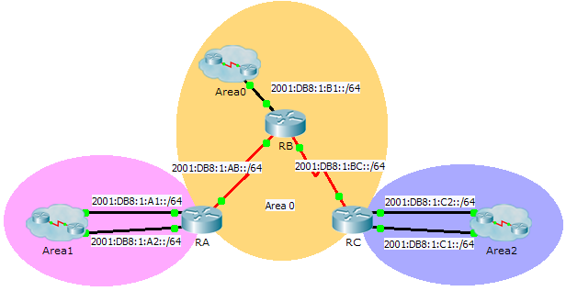

1. Addressing Table

|  |  |  |  |
| --- | --- | --- | --- |
| Device | Interface | IPv6 Address | OSPF Area |
| RA | G0/0 | 2001:DB8:1:A1::1/64 | 1 |
| G0/1 | 2001:DB8:1:A2::1/64 | 1 |
| S0/0/0 | 2001:DB8:1:AB::2/64 | 0 |
| Link-Local | FE80::A | N/A |
| RB | G0/0 | 2001:DB8:1:B1::1/64 | 0 |
| S0/0/0 | 2001:DB8:1:AB::1/64 | 0 |
| S0/0/1 | 2001:DB8:1:BC::1/64 | 0 |
| Link-Local | FE80::B | N/A |
| RC | G0/0 | 2001:DB8:1:C1::1/64 | 2 |
| G0/1 | 2001:DB8:1:C2::1/64 | 2 |
| S0/0/1 | 2001:DB8:1:BC::2/64 | 0 |
| Link-Local | FE80::C | N/A |

1. Objectives

Part 1: Configure OSPFv3

Part 2: Verify Multiarea OSPFv3 Operations

1. Background

In this activity, you will configure multiarea OSPFv3. The network is already connected and interfaces are configured with IPv6 addressing. Your job is to enable multiarea OSPFv3, verify connectivity and examine the operation of multiarea OSPFv3.

1. Configure OSPFv3
   1. Enable IPv6 routing and configure OSPFv3 on RA.
      1. Enable IPv6 routing.
      2. Configure OSPFv3 on RA with a process ID of 1 and a router ID of 1.1.1.1.
   2. Advertise each directly connected network in OSPFv3 on RA.

Configure each active IPv6 interface with OSPFv3 assigning each to the area listed in the **Addressing Table**.

* 1. Configure OSPFv3 on RB and RC

Repeat the Steps 1 and 2 for **RB** and **RC**, changing the router ID to 2.2.2.2 and 3.3.3.3 respectively.

1. Verify Multiarea OSPFv3 Operations
   1. Verify connectivity to each of the OSPFv3 areas.

From RA, ping each of the following remote devices in area 0 and area 2: 2001:DB8:1:B1::2, 2001:DB8:1:A1::2, 2001:DB8:1:A2::2, 2001:DB8:1:C1::2, and 2001:DB8:1:C2::2.

* 1. Use show commands to examine the current OSPFv3 operations.

Use the following commands to gather information about your OSPFv3 multiarea implementation.

**show ipv6 ospf**

**show ipv6 route**

**show ipv6 ospf database**

**show ipv6 ospf interface**

**show ipv6 ospf neighbor**

**Note:** Packet Tracer output for **show ipv6 protocols** is currently not aligned with IOS 15 output. Refer to the real equipment labs for correct **show** command output.